|  |  |
| --- | --- |
|  | **Fakulti Teknologi Kejuruteraan Kelautan dan Informatik, Universiti Malaysia Terengganu** |

**Lab Manual Week 7**

**Web Programming**

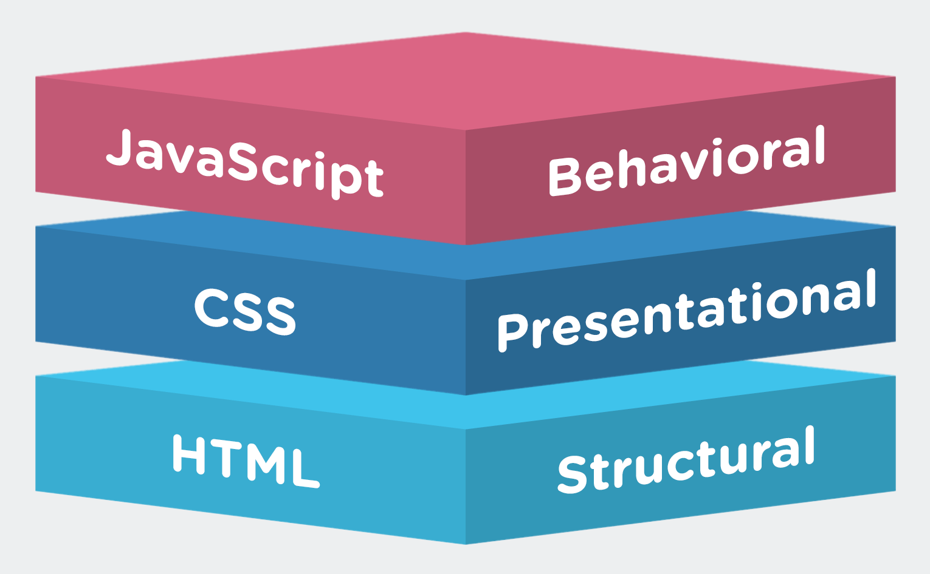

|  |  |  |
| --- | --- | --- |
| **Name** | **:** | **ARUN MUGILAN** |
| **Matric Num** | **:** | **S63746** |
| **Semester** | **:** | **3** |
| **Lab** | **:** | **MP3** |
| **Demonstrator** | **:** | **MR. ARIZAL** |

**Instructions**

This lab manual is for used by students at the School of Informatics and Applied Mathematics, Universiti Malaysia Terengganu (UMT) only. Not allowed to print and distribute this manual without official permission of the author.

Please follow the step by step as described in the manual. Tick (√) each step has been created and write the conclusion of each activity has been completed.

Conclusion or result of each activity must be written in a file named according to the following format:

[nomatrik] _ [LabX]. docx. Replace the 'X' with your lab session. Examples of correct file name is 'UK12345_Lab1.docx'.

Please prepare the assignments with your individual effort without any 'copy-paste' from other parties.

Best of luck!

**JAVASCRIPT, HTML, AND CSS**

**Objective:**

1. Students are able to combine HTML, CSS, and Javascript, in order to develop an interactive website.

**Explanation:**

We should realize, the HTML, CSS, and JavaScript each of them is playing a completely difference role and they work seamlessly together.

1. HTML provides the basic structure of sites, which is enhanced and modified by other technologies like CSS and JavaScript.
2. CSS is used to control presentation, formatting, and layout.
3. JavaScript is used to control the behavior of different elements.

**HTML & CSS**

HTML provides the raw tools needed to structure content on a website. CSS, on the other hand, helps to style this content so it appears to the user the way it was intended to be seen. These languages are kept separate to ensure websites are built correctly before they're reformatted.

If HTML is the drywall, CSS is the paint.

Whereas HTML was the basic structure of your website, CSS is what gives your entire website its style. Those slick colors, interesting fonts, and background images? All thanks to CSS. This language affects the entire mood and tone of a web page, making it an incredibly powerful tool -- and an important skill for web developers to learn. It's also what allows websites to adapt to different screen sizes and device types.

**JAVASCRIPT**

In short, JavaScript is a programming language that lets web developers design interactive sites. Most of the dynamic behavior you'll see on a web page is thanks to JavaScript, which augments a browser's default controls and behaviors.

All images can be downloaded from: <https://bit.ly/3869ToU>

**Activity 1**

Create a Transparent Image Text

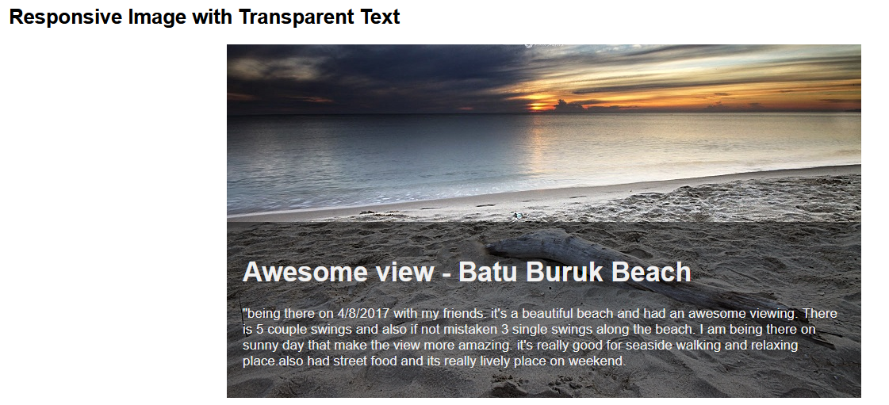

Step 1) Add HTML:

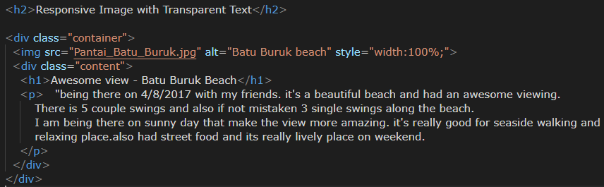

"being there on 4/8/2017 with my friends. it's a beautiful beach and had an awesome viewing.

There are 5 couple swings and also if not mistaken 3 single swings along the beach.

I am being there on sunny day that make the view more amazing. It's really good for seaside walking and relaxing place. It also had street food and it’s lively place on weekend.

Step 2) Add CSS:

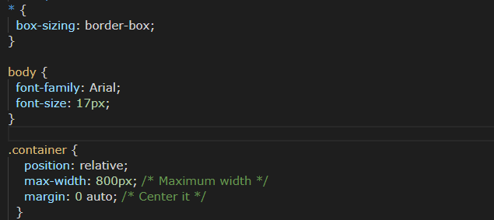

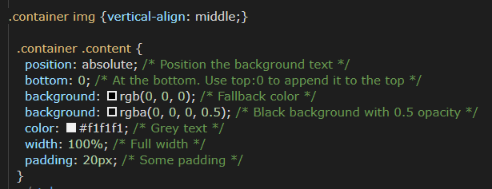

**Conclusion and Result:**

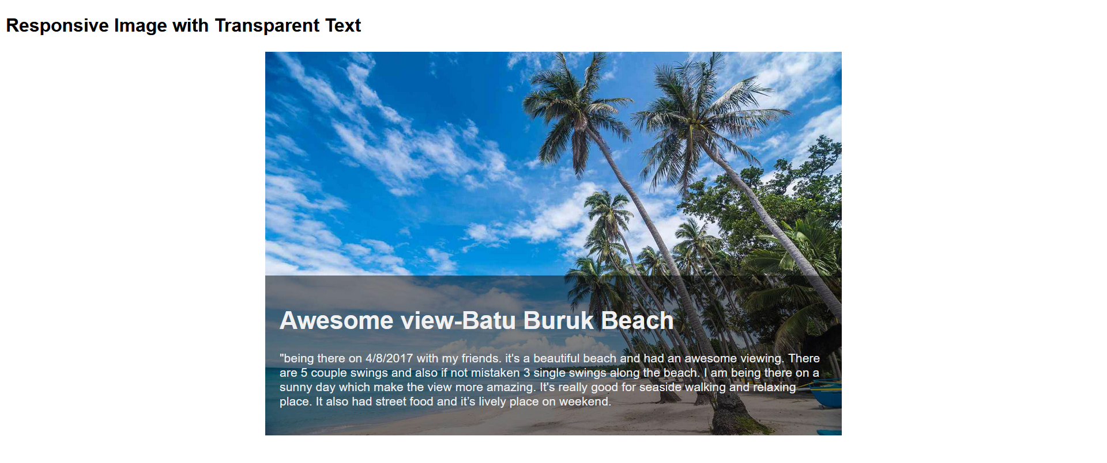

**Activity 2**

Create a Form on Image

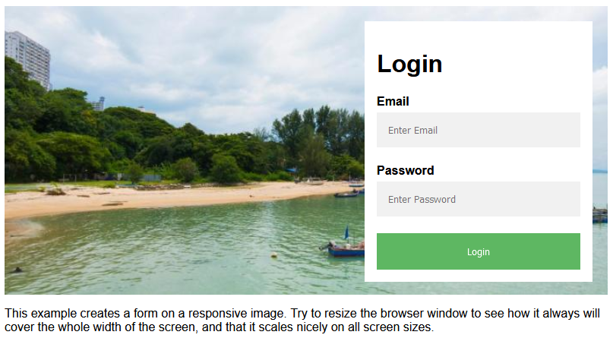

Step 1. Add HTML :

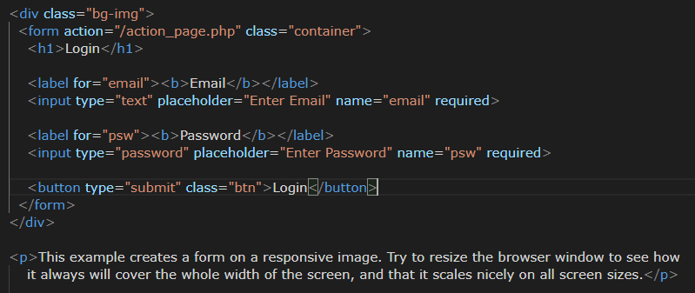

The first result will be:

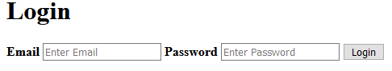

Step 2. Add CSS

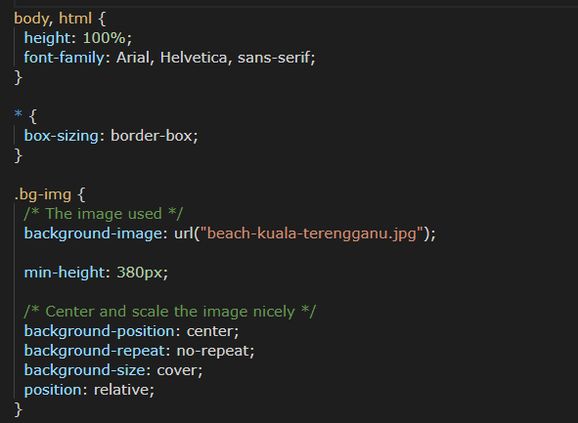

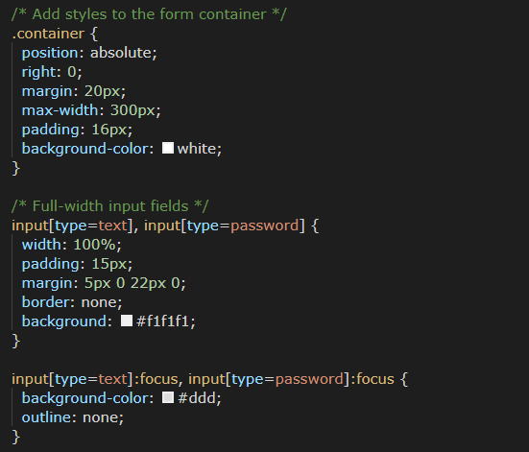

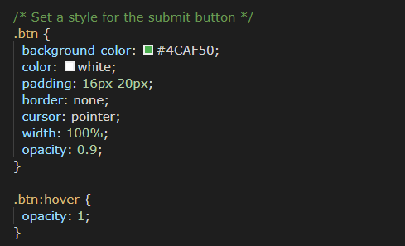

**Conclusion and Result:**

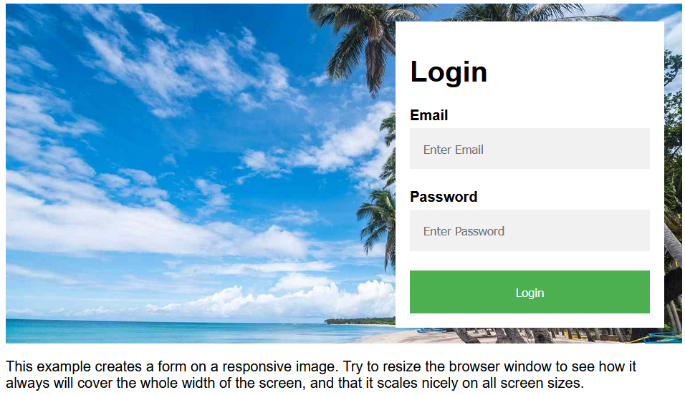

**Activity 3**

Create a Side Navigation Buttons

Step 1. Add this HTML:

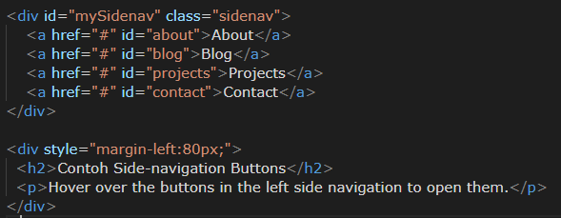

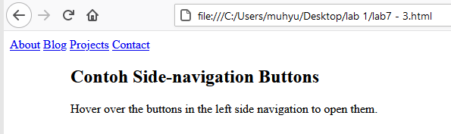

Step 2. Add the CSS:

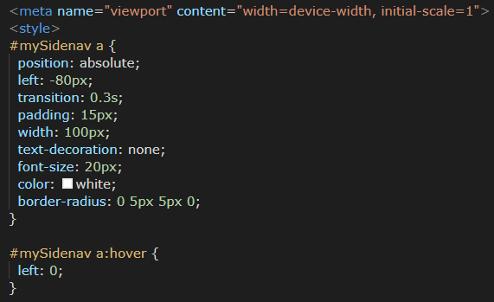

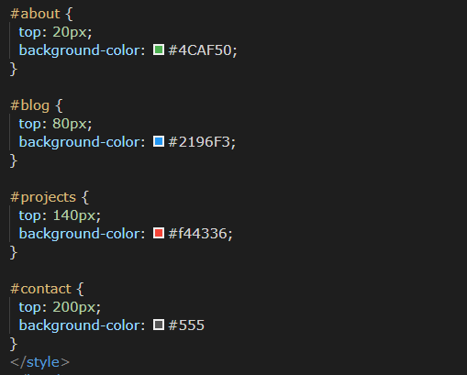

**Conclusion and Result:**

**Activity 4**

Create Automatic Slideshow

Step 1) Add HTML:

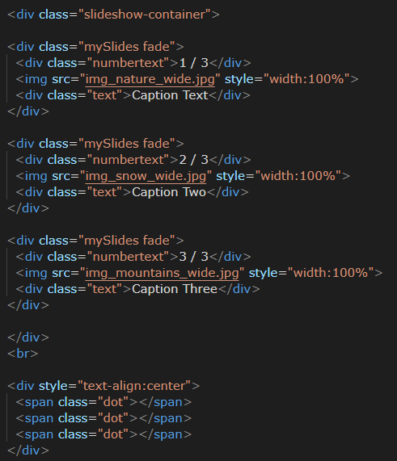

Step 2) Add CSS:

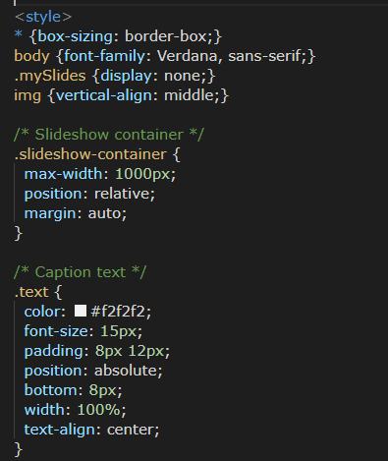

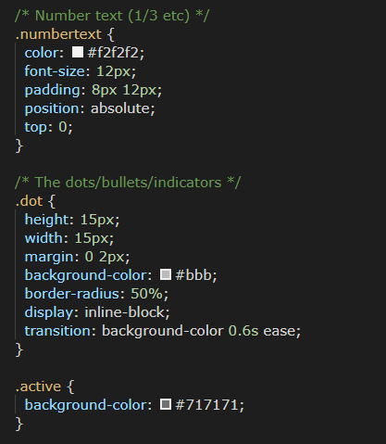

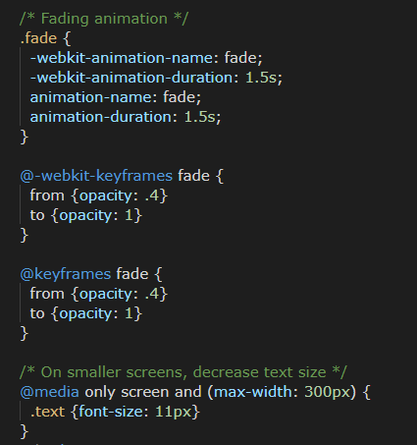

Step 3) Add Javascript:

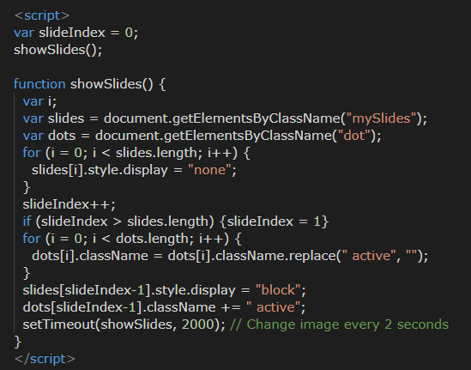

**Conclusion and Result:**

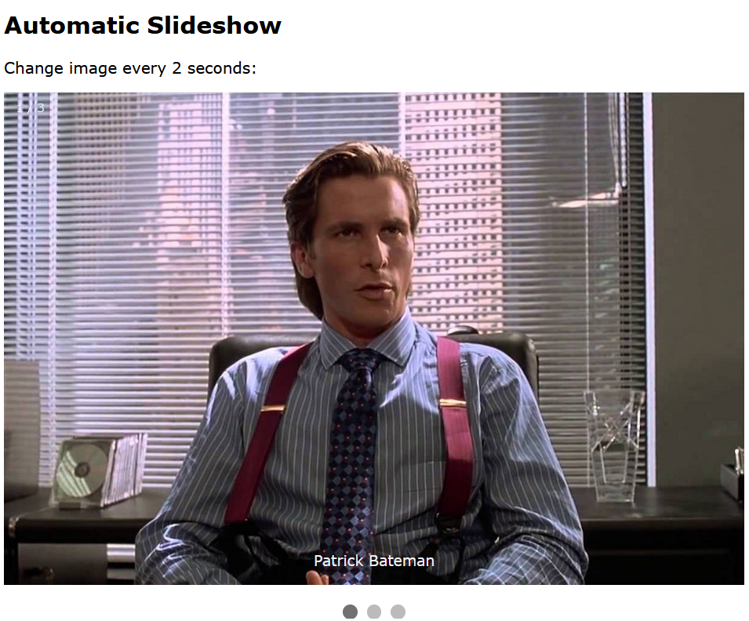

**Activity 5**

Create Profile Card

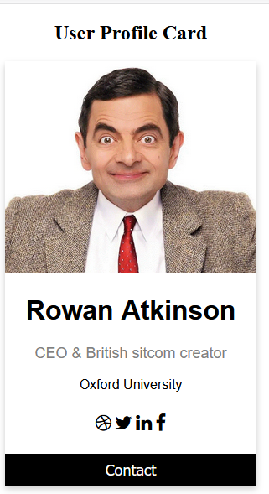

Step 1) Add HTML:

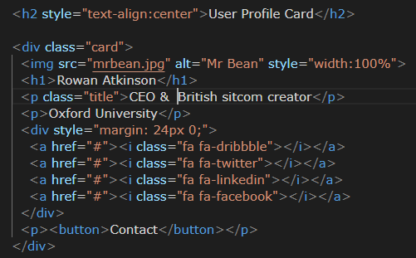

Step 2) Add CSS:

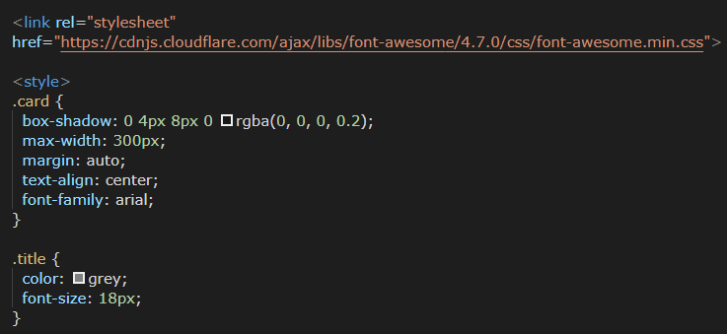

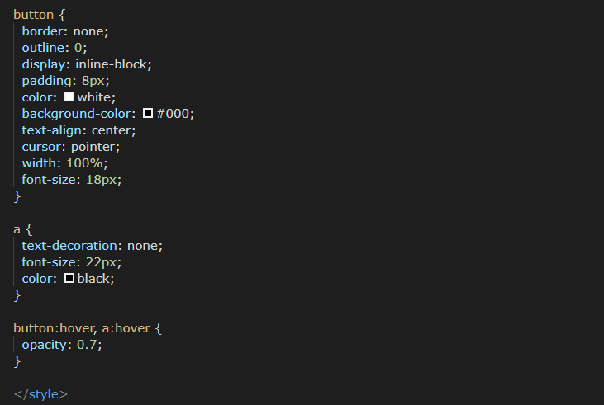

**Conclusion and Result:**

**Activity 6**

Create Progress Bar

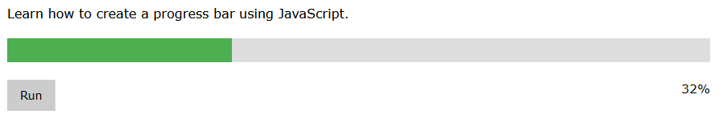

Step 1) Add HTML:

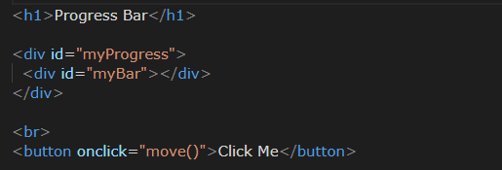

Step 2) Add CSS:

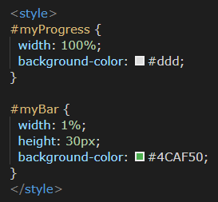

Step 3) Add Javascript:

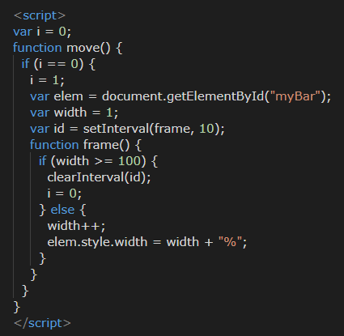

**Conclusion and Result:**

**Activity 7**

Create A Collapsible

For instance, click the button to toggle between showing and hiding the collapsible content.

Step 1) Add HTML:

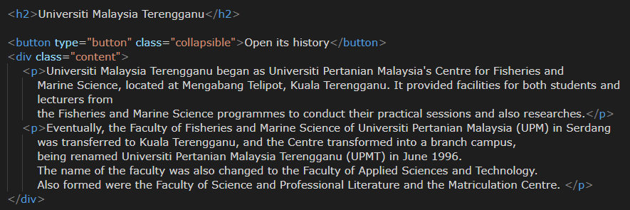

Text :

<p>Universiti Malaysia Terengganu began as Universiti Pertanian Malaysia's Centre for Fisheries and Marine Science, located at Mengabang Telipot, Kuala Terengganu. It provided facilities for both students and lecturers from the Fisheries and Marine Science programmes to conduct their practical sessions and also researches. </p>

<p>Eventually, the Faculty of Fisheries and Marine Science of Universiti Pertanian Malaysia (UPM) in Serdang was transferred to Kuala Terengganu, and the Centre transformed into a branch campus, being renamed Universiti Pertanian Malaysia Terengganu (UPMT) in June 1996. The name of the faculty was also changed to the Faculty of Applied Sciences and Technology. Also formed were the Faculty of Science and Professional Literature and the Matriculation Centre. </p>

Step 2) Add CSS:

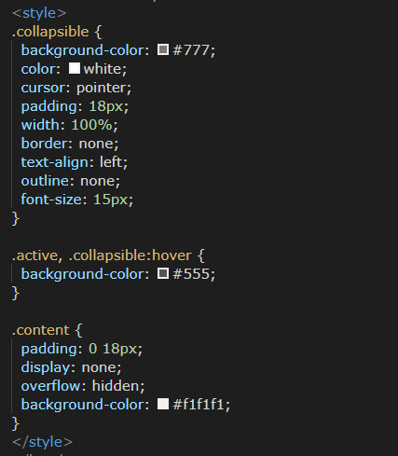

Step 3) Add Javascript:

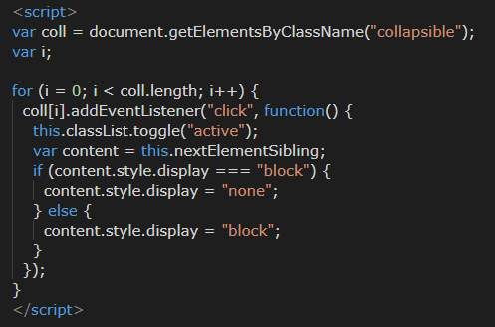

**Conclusion and Result:**



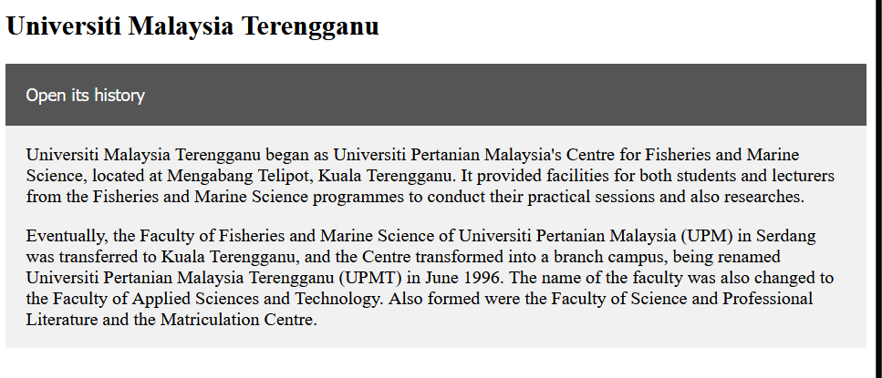

Lab 7 Exercise:

1. Create a form for inputing costumer data (including address and email) with picture as a background.
2. From activity 4, please create a slideshow of some Terengganu market’s images. After that create a link for each image to the website/blog/news which has a content about the detail of market.
3. Create your own profile card. Make some modifications.
4. Modify activity 6, add labels to indicate how far the user is in the process, add a new element inside (or outside) the progress bar:

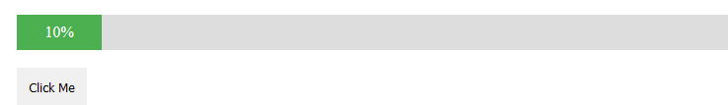

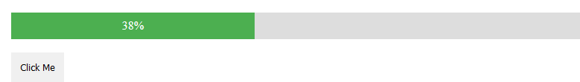

1. Make a collapsible set of Mr Bean movie

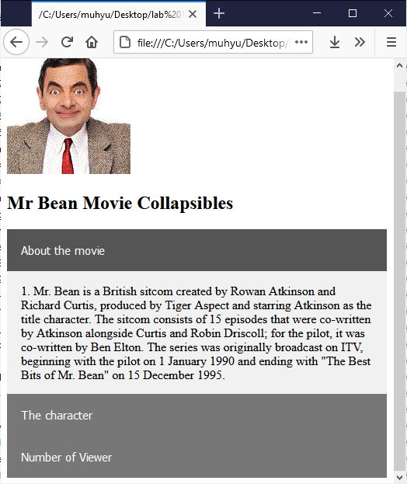

Please use these texts:

1. (About the movie) Mr. Bean is a British sitcom created by Rowan Atkinson and Richard Curtis, produced by Tiger Aspect and starring Atkinson as the title character. The sitcom consists of 15 episodes that were co-written by Atkinson alongside Curtis and Robin Driscoll; for the pilot, it was co-written by Ben Elton. The series was originally broadcast on ITV, beginning with the pilot on 1 January 1990 and ending with "The Best Bits of Mr. Bean" on 15 December 1995.
2. (The Character) Based on a character originally developed by Atkinson while he was studying for his master's degree at Oxford University, the series centres on Mr. Bean, described by Atkinson as "a child in a grown man's body", as he solves various problems presented by everyday tasks and often causes disruption in the process. The series has been influenced by physical comedy actors such as Jacques Tati and those from early silent films.
3. (Numberof Viewers) During its original five-year run, Mr. Bean met with widespread acclaim and attracted large television audiences. The series was viewed by 18.74 million viewers for the episode "The Trouble with Mr. Bean". The series has also been sold in 245 territories worldwide and has inspired an animated spin-off and two theatrical feature-length films along with Atkinson reprising his role as Mr. Bean for a performance at the London 2012 Summer Olympics opening ceremony, television commercials and several sketches for Comic Relief. Besides the acclaim of the show, another reason for the show's appeal in hundreds of territories worldwide is that the show uses very little intelligible dialogue, making it accessible to people who know little or no English.